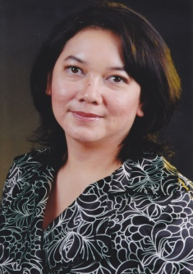

Agnes Irwanti, Co-founder of Multikom Global Mediatama company, Indonesia

Biodata: Agnes Irwanti is active in IEEE Indonesia section, as treasurer (2015 – now), Secretary for Comsoc Chapter (March 2013 – 2014), General Secretary IEEE Indonesia Section (Feb 2012 – March 2013), Women in Engineering Coordinator (Jan 2011 – Feb 2012). In the profesional role, she is business strategic and development director as well as co-founder of Multikom Global Mediatama company, which focuses its service in products and consulting in Broadcast Industry in Indonesia. She is one of the few activist women in Indonesian ICT. Beyond her professional role, she’s committed to bridging the digital gap caused by gender or rural-urban disparity. Agnes pioneered a movement of knowledge sharing and training for women and marginalized groups to help them utilize ICT to improve their lives. For her efforts, she was named as one of the 2011 Most
Inspiring Women in Engineering by IEEE R10. She was also one of expert commentators on 'She will innovate competition 2012' by ASHOKA Change maker & INTEL. Frequently, Agnes appointed by Indonesia Government as Indonesia Delegation to attend International conferences, such as APEC Women & the Economic Forum (2013, 2011), APEC Women in The APEC Economic Summit (2011) & APEC Women Leaders Conference (2009, 2010), as well as she also invited to be International and National speaker and lecturer. Agnes has passion and specialties in Business Strategy, Change Management , Knowledge Management and Entrepreneurship.

