T K ANURADHA
Program Director, GEOSAT, ISRO Satellite Centre
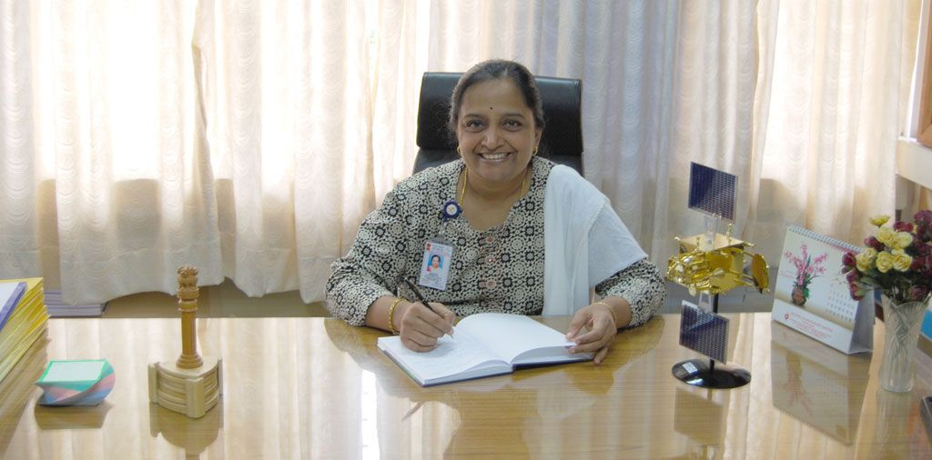

Smt T K Anuradha completed B E, Electronics; 1982 UVCE, Bangalore and joined ISRO in the same year. As Project Director, Successfully completed the realisation of GSAT-12, a communication satellite uniquely built on I-1K bus; GSAT-10, the heaviest Communication satellite from India on I-3K bus & presently realising GSAT-9, GSAT-17 and GSAT-18 communication satellites. She has served as the head of the technical group with nearly 20 engineers and was responsible for the design of many digital and Power electronic based systems; Instrumentation & automation. These were successfully inducted in the Spacecraft evaluation systems. She has played the lead role in Indian Space programs as Project Manager, Deputy Project Director and Associate Project Director for Indian Remote Sensing and Indian Navigation programs.
She is the author of various papers in refereed journals & delivered distinguished lectures. She is the recipient of numerous awards, some of them include "Space Gold Medal award – 2003" by Astronautical Society of India for the services in the field of Space sciences, "Suman Sharma Award – 2011" by National Design and Research Forum (NDRF) of IEI and "ASI- ISRO Merit Award 2012" for realisation of indigenous Communication spacecraft and "ISRO Team Award 2012” as the team leader for the realisation of GSAT-12.
Source:
http://jeppiaartech.in/femfest2014/index.php/component/k2/item/280-t-k-anuradha

